Instalación de correo corporativo con Postfix y Dovecot.
Actividad 1.6

Cristóbal Suárez Abad
Administración de Sistemas Operativos - 2º ASIR

Contenido
Instalación de correo corporativo con Postfix y Dovecot. 2
1) Instalamos: 2
2) Configuración de archivos: 2
a) Creación de usuario para Dovecot: 2
b) Configuración de Postfix: 3
3) Crear directorios de correo. 17
4) Reiniciar servicios. 17
5) Creamos usuarios con correo en LDAP. 18
6) Instalamos swak para probar el correo. 19
Instalar OwnCloud 20
1) Instalamos Docker en el servidor. 20

Instalación de correo corporativo con Postfix y Dovecot.

Instalamos:
sudo apt update
sudo apt install postfix postfix-ldap dovecot-core dovecot-imapd dovecot-ldap libsasl2-modules-ldap

Configuración de archivos:

Creación de usuario para Dovecot:
Crearemos un usuario de sistema (vmail) sin privilegios de shell. Dovecot usará este usuario para escribir todos los correos en el disco, evitando problemas de permisos.
sudo useradd -r -s /sbin/nologin vmail

Configuración de Postfix:
sudo nano /etc/postfix/main.cf
# See /usr/share/postfix/main.cf.dist for a commented, more complete version

# Debian specific: Specifying a file name will cause the first
# line of that file to be used as the name. The Debian default
# is /etc/mailname.
#myorigin = /etc/mailname

smtpd_banner = $myhostname ESMTP $mail_name (Ubuntu)
biff = no

# appending .domain is the MUA's job.
append_dot_mydomain = no

# Uncomment the next line to generate "delayed mail" warnings
#delay_warning_time = 4h

readme_directory = no

# See http://www.postfix.org/COMPATIBILITY_README.html -- default to 3.6 on
# fresh installs.
compatibility_level = 3.6

# --- Autenticación SASL vía Dovecot ---
smtpd_sasl_type = dovecot
smtpd_sasl_path = private/auth
smtpd_sasl_auth_enable = yes
smtpd_sasl_security_options = noanonymous
smtpd_sasl_local_domain = $mydomain

# --- Restricciones de Envío ---
smtpd_recipient_restrictions = permit_sasl_authenticated, permit_mynetworks, reject_unauth_destination

# --- Configuración de Dominio y Entrega ---
virtual_mailbox_domains = SUAREZ1.abad2
virtual_transport = lmtp:unix:private/dovecot-lmtp
# --- Mapa de consulta LDAP ---
virtual_mailbox_maps = ldap:/etc/postfix/ldap-virtual-mailbox-maps.cf

# TLS parameters
smtpd_tls_cert_file=/etc/ssl/certs/ssl-cert-snakeoil.pem
smtpd_tls_key_file=/etc/ssl/private/ssl-cert-snakeoil.key
smtpd_tls_security_level=may
smtpd_use_tls = yes

smtp_tls_CApath=/etc/ssl/certs
smtp_tls_security_level=encrypt
smtp_tls_session_cache_database = btree:${data_directory}/smtp_scache

relayhost = [smtp.gmail.com]:587
smtp_sasl_auth_enable = yes
smtp_sasl_password_maps = hash:/etc/postfix/sasl_passwd
smtp_sasl_security_options = noanonymous
smtp_use_tls = yes
# REPETIDA smtp_tls_security_level = encrypt
smtp_tls_CAfile = /etc/ssl/certs/ca-certificates.crt

smtpd_relay_restrictions = permit_mynetworks permit_sasl_authenticated defer_unauth_destination
myhostname = control01.SUAREZ1.abad2
alias_maps = hash:/etc/aliases
alias_database = hash:/etc/aliases
myorigin = /etc/mailname
mydestination = $myhostname, localhost.$mydomain, localhost
#mydestination = $myhostname, SUAREZ1.abad2, control01.SUAREZ1.abad2, localhost.SUAREZ1.abad2, localhost
relayhost = [smtp.gmail.com]:587
mynetworks = 127.0.0.0/8 [::ffff:127.0.0.0]/104 [::1]/128
mailbox_size_limit = 0
recipient_delimiter = +
inet_interfaces = all
inet_protocols = all

sudo nano /etc/postfix/ldap-virtual-mailbox-maps.cf
server_host = 127.0.0.1
search_base = ou=usuarios,dc=SUAREZ1,dc=abad2
query_filter = (mail=%s)
result_attribute = mail
bind = yes
bind_dn = cn=admin,dc=SUAREZ1,dc=abad2
bind_pw = usuario.12345

sudo nano /etc/postfix/master.cf

#
# Postfix master process configuration file. For details on the format
# of the file, see the master(5) manual page (command: "man 5 master" or
# on-line: http://www.postfix.org/master.5.html).
#
# Do not forget to execute "postfix reload" after editing this file.
#
# ==========================================================================
# service type private unpriv chroot wakeup maxproc command + args
# (yes) (yes) (no) (never) (100)
# ==========================================================================
smtp inet n - y - - smtpd
#smtp inet n - y - 1 postscreen
#smtpd pass - - y - - smtpd
#dnsblog unix - - y - 0 dnsblog
#tlsproxy unix - - y - 0 tlsproxy
# Choose one: enable submission for loopback clients only, or for any client.
#127.0.0.1:submission inet n - y - - smtpd
submission inet n - y - - smtpd
# -o syslog_name=postfix/submission
-o smtpd_tls_security_level=encrypt
-o smtpd_sasl_auth_enable=yes
# -o smtpd_tls_auth_only=yes
# -o smtpd_reject_unlisted_recipient=no
-o smtpd_client_restrictions=permit_sasl_authenticated,reject
# -o smtpd_client_restrictions=$mua_client_restrictions
# -o smtpd_helo_restrictions=$mua_helo_restrictions
# -o smtpd_sender_restrictions=$mua_sender_restrictions
# -o smtpd_recipient_restrictions=
# -o smtpd_relay_restrictions=permit_sasl_authenticated,reject
# -o milter_macro_daemon_name=ORIGINATING
# Choose one: enable smtps for loopback clients only, or for any client.
#127.0.0.1:smtps inet n - y - - smtpd
#smtps inet n - y - - smtpd
# -o syslog_name=postfix/smtps
-o smtpd_tls_wrappermode=no
# -o smtpd_sasl_auth_enable=yes
# -o smtpd_reject_unlisted_recipient=no
# -o smtpd_client_restrictions=$mua_client_restrictions
# -o smtpd_helo_restrictions=$mua_helo_restrictions
# -o smtpd_sender_restrictions=$mua_sender_restrictions
# -o smtpd_recipient_restrictions=
# -o smtpd_relay_restrictions=permit_sasl_authenticated,reject
# -o milter_macro_daemon_name=ORIGINATING
#628 inet n - y - - qmqpd
pickup unix n - y 60 1 pickup
cleanup unix n - y - 0 cleanup
qmgr unix n - n 300 1 qmgr
#qmgr unix n - n 300 1 oqmgr
tlsmgr unix - - y 1000? 1 tlsmgr
rewrite unix - - y - - trivial-rewrite
bounce unix - - y - 0 bounce
defer unix - - y - 0 bounce
trace unix - - y - 0 bounce
verify unix - - y - 1 verify
flush unix n - y 1000? 0 flush
proxymap unix - - n - - proxymap
proxywrite unix - - n - 1 proxymap
smtp unix - - y - - smtp
relay unix - - y - - smtp
-o syslog_name=postfix/$service_name
# -o smtp_helo_timeout=5 -o smtp_connect_timeout=5
showq unix n - y - - showq
error unix - - y - - error
retry unix - - y - - error
discard unix - - y - - discard
local unix - n n - - local
virtual unix - n n - - virtual
lmtp unix - - y - - lmtp
anvil unix - - y - 1 anvil
scache unix - - y - 1 scache
postlog unix-dgram n - n - 1 postlogd
#
# ====================================================================
# Interfaces to non-Postfix software. Be sure to examine the manual
# pages of the non-Postfix software to find out what options it wants.
#
# Many of the following services use the Postfix pipe(8) delivery
# agent. See the pipe(8) man page for information about ${recipient}
# and other message envelope options.
# ====================================================================
#
# maildrop. See the Postfix MAILDROP_README file for details.
# Also specify in main.cf: maildrop_destination_recipient_limit=1
#
maildrop unix - n n - - pipe
flags=DRXhu user=vmail argv=/usr/bin/maildrop -d ${recipient}
#
# ====================================================================
#
# Recent Cyrus versions can use the existing "lmtp" master.cf entry.
#
# Specify in cyrus.conf:
# lmtp cmd="lmtpd -a" listen="localhost:lmtp" proto=tcp4
#
# Specify in main.cf one or more of the following:
# mailbox_transport = lmtp:inet:localhost
# virtual_transport = lmtp:inet:localhost
#
# ====================================================================
#
# Cyrus 2.1.5 (Amos Gouaux)
# Also specify in main.cf: cyrus_destination_recipient_limit=1
#
#cyrus unix - n n - - pipe
# flags=DRX user=cyrus argv=/cyrus/bin/deliver -e -r ${sender} -m ${extension} ${user}
#
# ====================================================================
# Old example of delivery via Cyrus.
#
#old-cyrus unix - n n - - pipe
# flags=R user=cyrus argv=/cyrus/bin/deliver -e -m ${extension} ${user}
#
# ====================================================================
#
# See the Postfix UUCP_README file for configuration details.
#
uucp unix - n n - - pipe
flags=Fqhu user=uucp argv=uux -r -n -z -a$sender - $nexthop!rmail ($recipient)
#
# Other external delivery methods.
#
ifmail unix - n n - - pipe
flags=F user=ftn argv=/usr/lib/ifmail/ifmail -r $nexthop ($recipient)
bsmtp unix - n n - - pipe
flags=Fq. user=bsmtp argv=/usr/lib/bsmtp/bsmtp -t$nexthop -f$sender $recipient
scalemail-backend unix - n n - 2 pipe
flags=R user=scalemail argv=/usr/lib/scalemail/bin/scalemail-store ${nexthop} ${user} ${extension}
mailman unix - n n - - pipe
flags=FRX user=list argv=/usr/lib/mailman/bin/postfix-to-mailman.py ${nexthop} ${user}
- Configuración de Dovecot.

sudo nano /etc/dovecot/conf.d/10-mail.conf

mail_location = maildir:/var/mail/vhosts/%d/%n
mail_uid = vmail
mail_gid = vmail

sudo nano /etc/dovecot/conf.d/10-auth.conf

disable_plaintext_auth = no
auth_mechanisms = plain login
# <doc/wiki/UserDatabase.txt>

#!include auth-deny.conf.ext
#!include auth-master.conf.ext

!include auth-system.conf.ext
#!include auth-sql.conf.ext
!include auth-ldap.conf.ext
#!include auth-passwdfile.conf.ext
#!include auth-checkpassword.conf.ext
#!include auth-static.conf.ext

sudo nano /etc/dovecot/conf.d/10-master.conf

service lmtp {
unix_listener /var/spool/postfix/private/dovecot-lmtp {
mode = 0660
user = postfix
group = postdrop
}

# Create inet listener only if you can't use the above UNIX socket
#inet_listener lmtp {
# Avoid making LMTP visible for the entire internet
#address =
#port =
#}
}

service auth {
unix_listener /var/spool/postfix/private/auth {
mode = 0660
user = postfix
group = postfix
}

# Postfix smtp-auth
#unix_listener /var/spool/postfix/private/auth {
# mode = 0666
#}

# Auth process is run as this user.
#user = $default_internal_user
}

sudo nano /etc/dovecot/conf.d/auth-ldap.conf.ext

# Authentication for LDAP users. Included from 10-auth.conf.
#
# <doc/wiki/AuthDatabase.LDAP.txt>

passdb {
driver = ldap

# Path for LDAP configuration file, see example-config/dovecot-ldap.conf.ext
args = /etc/dovecot/dovecot-ldap.conf.ext
}

# "prefetch" user database means that the passdb already provided the
# needed information and there's no need to do a separate userdb lookup.
# <doc/wiki/UserDatabase.Prefetch.txt>
#userdb {
# driver = prefetch
#}

userdb {
driver = ldap
args = /etc/dovecot/dovecot-ldap.conf.ext

# Default fields can be used to specify defaults that LDAP may override
#default_fields = home=/home/virtual/%u
}

# If you don't have any user-specific settings, you can avoid the userdb LDAP
# lookup by using userdb static instead of userdb ldap, for example:
# <doc/wiki/UserDatabase.Static.txt>
#userdb {
#driver = static
#args = uid=vmail gid=vmail home=/var/vmail/%u
#}

sudo nano /etc/dovecot/dovecot-ldap.conf.ext

# This file is commonly accessed via passdb {} or userdb {} section in
# conf.d/auth-ldap.conf.ext

# This file is opened as root, so it should be owned by root and mode 0600.
#
# http://wiki2.dovecot.org/AuthDatabase/LDAP
#
# NOTE: If you're not using authentication binds, you'll need to give
# dovecot-auth read access to userPassword field in the LDAP server.
# With OpenLDAP this is done by modifying /etc/ldap/slapd.conf. There should
# already be something like this:

# access to attribute=userPassword
# by dn="<dovecot's dn>" read # add this
# by anonymous auth
# by self write
# by * none

# Space separated list of LDAP hosts to use. host:port is allowed too.
hosts = 127.0.0.1

# LDAP URIs to use. You can use this instead of hosts list. Note that this
# setting isn't supported by all LDAP libraries.
#uris =

# Distinguished Name - the username used to login to the LDAP server.
# Leave it commented out to bind anonymously (useful with auth_bind=yes).
dn = cn=admin,dc=SUAREZ1,dc=abad2

# Password for LDAP server, if dn is specified.
dnpass = usuario.12345

# Use SASL binding instead of the simple binding. Note that this changes
# ldap_version automatically to be 3 if it's lower.
#sasl_bind = no
# SASL mechanism name to use.
#sasl_mech =
# SASL realm to use.
#sasl_realm =
# SASL authorization ID, ie. the dnpass is for this "master user", but the
# dn is still the logged in user. Normally you want to keep this empty.
#sasl_authz_id =

# Use TLS to connect to the LDAP server.
#tls = no
# TLS options, currently supported only with OpenLDAP:
#tls_ca_cert_file =
#tls_ca_cert_dir =
#tls_cipher_suite =
# TLS cert/key is used only if LDAP server requires a client certificate.
#tls_cert_file =
#tls_key_file =
# Valid values: never, hard, demand, allow, try
#tls_require_cert =

# Use the given ldaprc path.
#ldaprc_path =

# LDAP library debug level as specified by LDAP_DEBUG_* in ldap_log.h.
# -1 = everything. You may need to recompile OpenLDAP with debugging enabled
# to get enough output.
#debug_level = 0

# Use authentication binding for verifying password's validity. This works by
# logging into LDAP server using the username and password given by client.
# The pass_filter is used to find the DN for the user. Note that the pass_attrs
# is still used, only the password field is ignored in it. Before doing any
# search, the binding is switched back to the default DN.
auth_bind = yes

# If authentication binding is used, you can save one LDAP request per login
# if users' DN can be specified with a common template. The template can use
# the standard %variables (see user_filter). Note that you can't
# use any pass_attrs if you use this setting.
#
# If you use this setting, it's a good idea to use a different
# dovecot-ldap.conf.ext for userdb (it can even be a symlink, just as long as
# the filename is different in userdb's args). That way one connection is used
# only for LDAP binds and another connection is used for user lookups.
# Otherwise the binding is changed to the default DN before each user lookup.
#
# For example:
# auth_bind_userdn = cn=%u,ou=people,o=org
#
#auth_bind_userdn =

# LDAP protocol version to use. Likely 2 or 3.
#ldap_version = 3

# LDAP base. %variables can be used here.
# For example: dc=mail, dc=example, dc=org
base = dc=SUAREZ1,dc=abad2

# Dereference: never, searching, finding, always
#deref = never

# Search scope: base, onelevel, subtree
scope = subtree

# User attributes are given in LDAP-name=dovecot-internal-name list. The
# internal names are:
# uid - System UID
# gid - System GID
# home - Home directory
# mail - Mail location
#
# There are also other special fields which can be returned, see
# http://wiki2.dovecot.org/UserDatabase/ExtraFields
#user_attrs = homeDirectory=home,uidNumber=uid,gidNumber=gid

# Filter for user lookup. Some variables can be used (see
# http://wiki2.dovecot.org/Variables for full list):
# %u - username
# %n - user part in user@domain, same as %u if there's no domain
# %d - domain part in user@domain, empty if user there's no domain
user_filter = (&(objectClass=posixAccount)(uid=%u))

# Password checking attributes:
# user: Virtual user name (user@domain), if you wish to change the
# user-given username to something else
# password: Password, may optionally start with {type}, eg. {crypt}
# There are also other special fields which can be returned, see
# http://wiki2.dovecot.org/PasswordDatabase/ExtraFields
#pass_attrs = uid=user,userPassword=password

# If you wish to avoid two LDAP lookups (passdb + userdb), you can use
# userdb prefetch instead of userdb ldap in dovecot.conf. In that case you'll
# also have to include user_attrs in pass_attrs field prefixed with "userdb_"
# string. For example:
#pass_attrs = uid=user,userPassword=password,\
# homeDirectory=userdb_home,uidNumber=userdb_uid,gidNumber=userdb_gid

# Filter for password lookups
pass_filter = (&(objectClass=posixAccount)(uid=%u))

# Attributes and filter to get a list of all users
#iterate_attrs = uid=user
#iterate_filter = (objectClass=posixAccount)

# Default password scheme. "{scheme}" before password overrides this.
# List of supported schemes is in: http://wiki2.dovecot.org/Authentication
#default_pass_scheme = CRYPT

# By default all LDAP lookups are performed by the auth master process.
# If blocking=yes, auth worker processes are used to perform the lookups.
# Each auth worker process creates its own LDAP connection so this can
# increase parallelism. With blocking=no the auth master process can
# keep 8 requests pipelined for the LDAP connection, while with blocking=yes
# each connection has a maximum of 1 request running. For small systems the
# blocking=no is sufficient and uses less resources.
#blocking = no

Crear directorios de correo.

sudo mkdir -p /var/mail/vhosts/SUAREZ1.abad2
sudo chown -R vmail:vmail /var/mail/vhosts
sudo chmod -R 770 /var/mail/vhosts

Reiniciar servicios.

sudo systemctl restart postfix
sudo systemctl restart dovecot
sudo systemctl enable postfix dovecot

Creamos usuarios con correo en LDAP.

#MARTA

dn: uid=marta,ou=usuarios,dc=SUAREZ1,dc=abad2
objectClass: inetOrgPerson
objectClass: posixAccount
objectClass: top
cn: marta
sn: suarez
uid: marta
uidNumber: 100389
gidNumber: 100389
homeDirectory: /home/marta
loginShell: /bin/bash
mail: marta@SUAREZ1.abad2
userPassword: usuario.12345

#MIGUEL

dn: uid=miguel,ou=usuarios,dc=SUAREZ1,dc=abad2
objectClass: inetOrgPerson
objectClass: posixAccount
objectClass: top
cn: miguel
sn: suarez
uid: miguel
uidNumber: 100390
gidNumber: 100390
homeDirectory: /home/miguel
loginShell: /bin/bash
mail: miguel@SUAREZ1.abad2
userPassword: usuario.12345

ldapadd -x -D "cn=admin,dc=SUAREZ1,dc=abad2" -w "usuario.12345" -f usuariocorreo.ldif

Instalamos swak para probar el correo.

sudo apt install swaks -y

Probamos el correo:

swaks --to miguel@SUAREZ1.abad2m --from marta@SUAREZ1.abad2 --server localhost:587 --auth LOGIN --auth-user marta -auth-password usuario.12345 --tls

Instalar OwnCloud

Vamos a usar un contenedor de Owncloud.

Instalamos Docker en el servidor.

Vamos a instalar en el servidor de LDAP un contenedor. Para ello debemos instalar previamente Docker.

Seguimos la guía de la página oficial: https://docs.docker.com/engine/install/ubuntu/

# Add Docker's official GPG key:
sudo apt-get update
sudo apt-get install ca-certificates curl
sudo install -m 0755 -d /etc/apt/keyrings
sudo curl -fsSL https://download.docker.com/linux/ubuntu/gpg -o /etc/apt/keyrings/docker.asc
sudo chmod a+r /etc/apt/keyrings/docker.asc

# Add the repository to Apt sources:
echo \
"deb [arch=$(dpkg --print-architecture) signed-by=/etc/apt/keyrings/docker.asc] https://download.docker.com/linux/ubuntu \
$(. /etc/os-release && echo "${UBUNTU_CODENAME:-$VERSION_CODENAME}") stable" | \
sudo tee /etc/apt/sources.list.d/docker.list > /dev/null
sudo apt-get update

Luego procedemos con la instalación:

sudo apt-get install docker-ce docker-ce-cli containerd.io docker-buildx-plugin docker-compose-plugin

sudo systemctl status docker

Comprobamos: sudo docker run hello-world

Creamos el contenedor de owncloud:

docker run -d --name ct_owncloud -p 8080:80 owncloud

Una vez iniciado, ponemos en la URL de nuestro navegador web:

Ip_del_servidor:8080
Ejemplo: 10.2.17.10:8080

Después, para entrar usamos el usuario y la contraseña “admin”. Después establecemos un usuario principal (podemos usar el de antes).

Una vez dentro vamos a Market e instalamos el modulo de LDAP Integration.
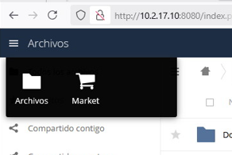
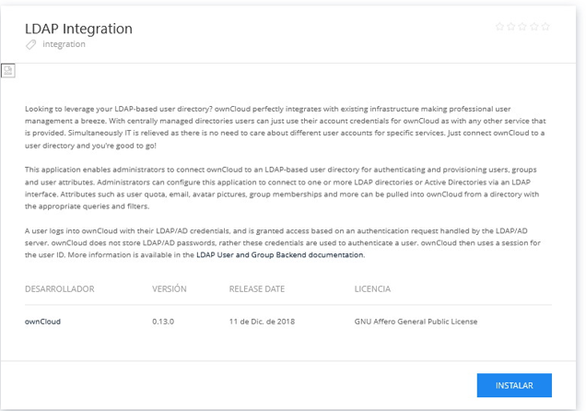

Después nos vamos a “Ajustes”.
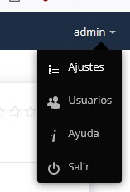
Autenticación de Usuario.

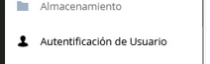

Rellenamos la información con los datos de nuestro servidor.

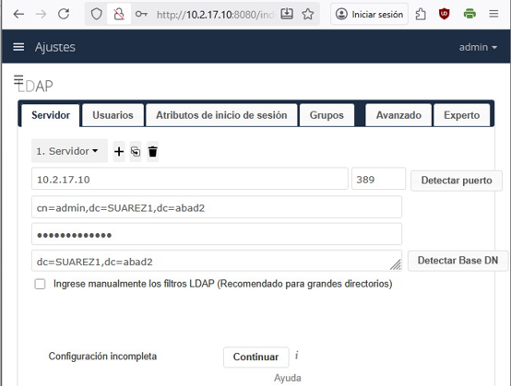
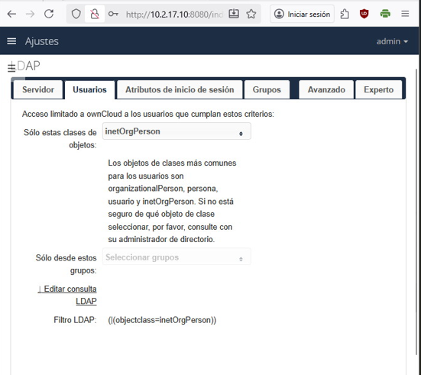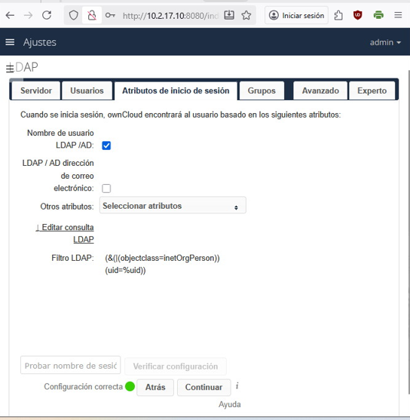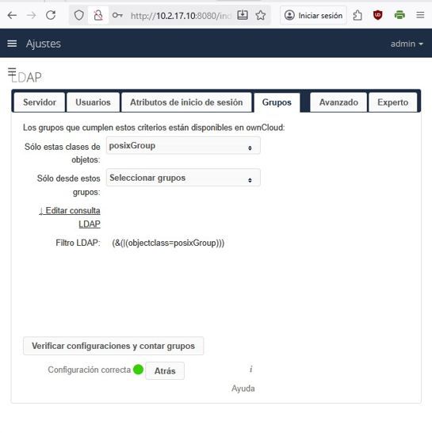
Después salimos y comprobamos su funcionamiento con otro usuario.

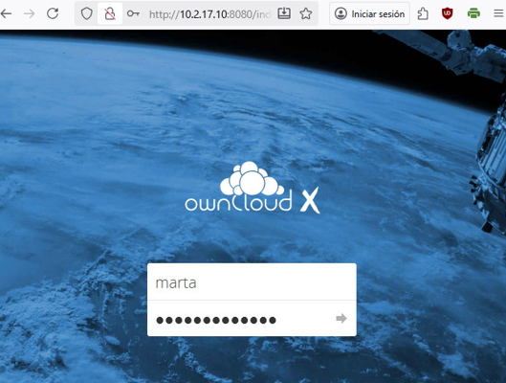

Guardamos un documento en el usuario Marta.
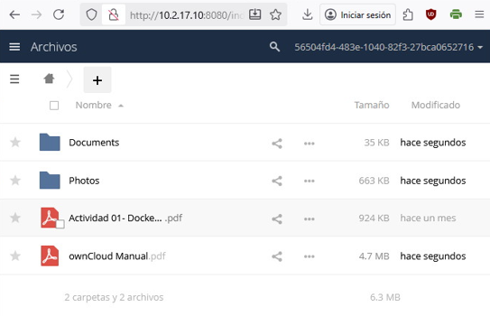
Nos salimos y comprobamos con otro usuario que solo está para Marta.
